

**NEW ZEALAND MARITIME SCHOOL**

**NZ Diploma Electro-technology**

**Year 1 ETO Cadets, 2019.**

**NZ2511-02.**

**(STCW-78 III/1, as amended in 2010)**

**Course 942.466**

**‘Safe Use of Electrical Equipment’**

**Learning Outcomes Assessment**

***Research each of the FOUR Learning Outcomes and answer with your interpretation.***

***You may work individually or as a team but you must name the team members.***

***Use reading material provided on Canvas, library material or other suitable sources. Where possible provide reference to the sources. Email back to the tutor when complete.***

**Tutor**: Nick Cossar

[nick.cossar@manukau.ac.nz](mailto:nick.cossar@manukau.ac.nz)

john.lamb@manukau.ac.nz

Student Name: Levi Shane Dubbelman

Student ID: 190000929

Team Members:

Date: 19th of February 2019

Learning Outcome 1: Follow safety instructions of electrical equipment and machinery

* Describe the generation and distribution of electrical power.
* Describe the use and purpose of implementation of a "three phase-three wire, insulated neutral system" for shipboard application.
* Demonstrate basic knowledge of structure of electrical switchboards.
* Identify safety precautions before commencing work or repair.

On the vast majority of ships active today, electrical power comes in two primary categories of voltages. These are low voltage electrical power (Anything less than 1000 Volts) and high voltage electrical power (Anything greater than 1000 Volts). The majority of ships active today rely on three-phase alternating current electrical power. In addition, it is N.A.T.O. (North Atlantic Treaty Organization) convention to use an alternating current frequency of 60 Hz. Interestingly, ships of the Soviet Union relied on a 50 Hz frequency, and were unmistakeable by their unique radar patterns during the Cold War. It is this military origin, as well as the forerunner of the electrification of vessels, the United States, using 60 Hz on shore-based applications. Unlike in airplane engines, however, which use 400 Hz to minimize the weight of the vessel, it is more convenient to use a standardized alternating current frequency between shore and ship to allow a connection to shore power when docked without a costly rectifier-inverted setup.

Shipboard electrical systems transmit power from their main alternators onto large bus bars, connected to a primary switchboard. Depending on the size of the ship, there may also be a secondary or tertiary bus bar and switchboard connected to the main switchboard via bus ties. Generally speaking, these additional bus bars are connected to their own supplementary generators, so in the event of a critical power failure, the ship is still able to generate and consume electrical power. In some situations, it may even have enough electrical power generation to provide propulsion. Another advantage of this system of redundancies is the ability to micro-manage power generation to suit the requirements of the existing load, which maximizes fuel efficiency. In addition, under the S.O.L.A.S. (Safety Of Life At Sea) convention, vessels are required to house an emergency generator, which is also connected to an emergency switchboard. This emergency switchboard is connected to the primary switchboard via normally closed bus ties, and runs critical loads associated with ensuring the survival of passengers and crew. An example of a critical load is the shipboard lighting in areas like the engine room.

Lower voltage electrical power is achieved for specific purposes by step-down transformers. Once stepped down, electrical power can be provided to systems such as lighting at voltages similar to those found on shore. On passenger vessels, AC power can be provided in the form of sockets with which passengers can connect their devices from home, i.e. laptops, hairdryers. The majority of ships also include a battery array, for which the alternating current must be rectified by a series of diodes and capacitors into direct current, in order to charge the battery array. This battery array can be used for a number of systems, for example, the starter motor on the emergency generator.

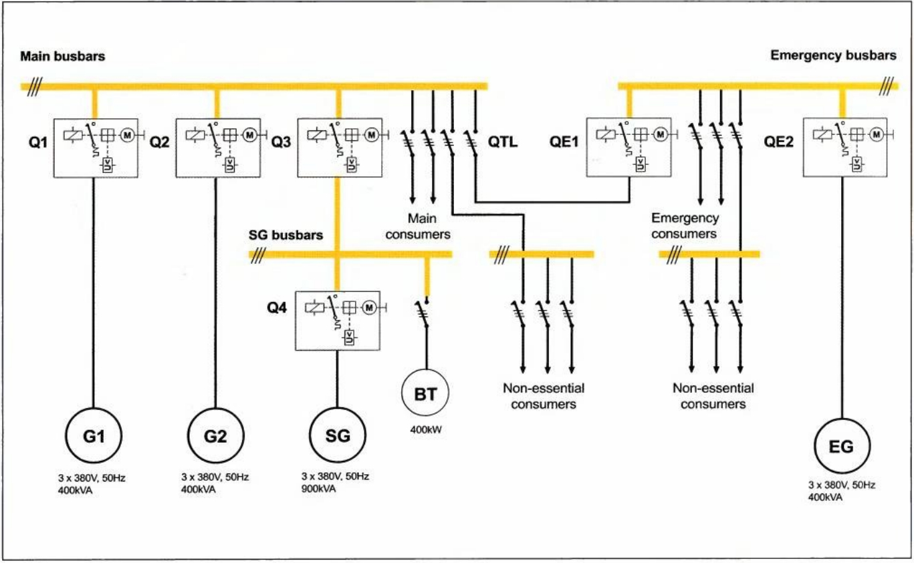

*Figure 1.1 Page 1 Chapter 1.1 - 3rd Edition Practical Marine Electrical Knowledge - Dennis T. Hall*

In the majority of shipboard electrical systems, an insulated neutral system is used. As mentioned previously, this system is three-wire three-phase alternating current. There are multiple advantages to this system. The primary advantage is redundancy. When a connection to earth (the ship’s hull), otherwise known as an earth fault, is made by one wire, perhaps exposed by the rigorous wear and tear sustained by all shipboard equipment, instead of making a short circuit and instantly tripping the circuit breaker, which in some applications could potentially result in an unsafe situation (e.g. a lack of lighting, or navigation). However, with the insulated distribution system, the equipment continues to operate normally because there is no complete circuit for current to flow. Though, if a second earth fault occurs on another line in the insulated system, a short circuit will occur and trip the circuit breaker, thus disconnecting the devices and potentially creating a risk to the safety of the ship and her crew and passengers.

Onboard ships, an electrician has a power set of tools available to their use in maintenance and monitoring, as well as assisting in ensuring safety of crew and protection from electrocution. In a standard switchboard, for example, there exists an overcurrent trip device to protect against short circuits, arc chutes to reduce the effect of discharging arcs when the breaker is tripped. On high voltage systems, generally these circuit breakers are contained in a vacuum or gas-filled insulator casings.

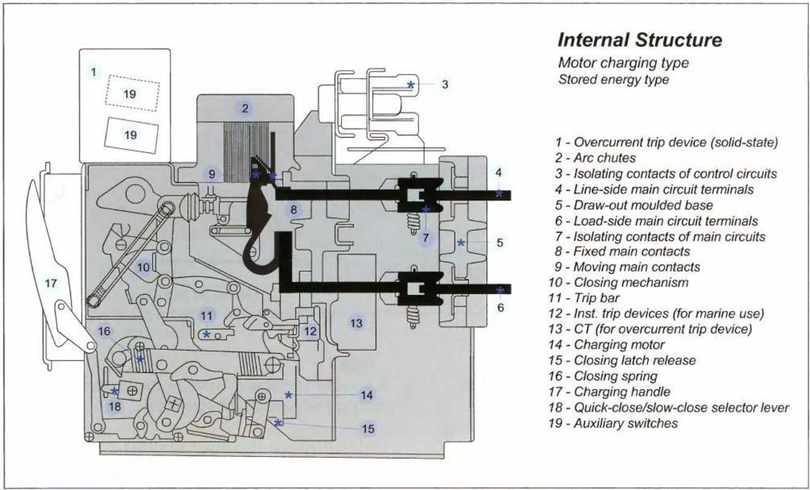

*Figure 3.19 Page 69 Chapter 3.1 - 3rd Edition Practical Marine Electrical Knowledge - Dennis T. Hall*

In addition, for monitoring, main switchboards can house several instruments such as ammeters, voltmeters, true power (watt meters), frequency meters and in some situations a power factor (cos θ gauge). For generators running parallel, there may also be a synchronoscope to ensure frequencies between generators are identical before closing a bus tie. These tools, combined with preferential trip switches, and isolators allow for effective and safe control of shipboard electrical systems.

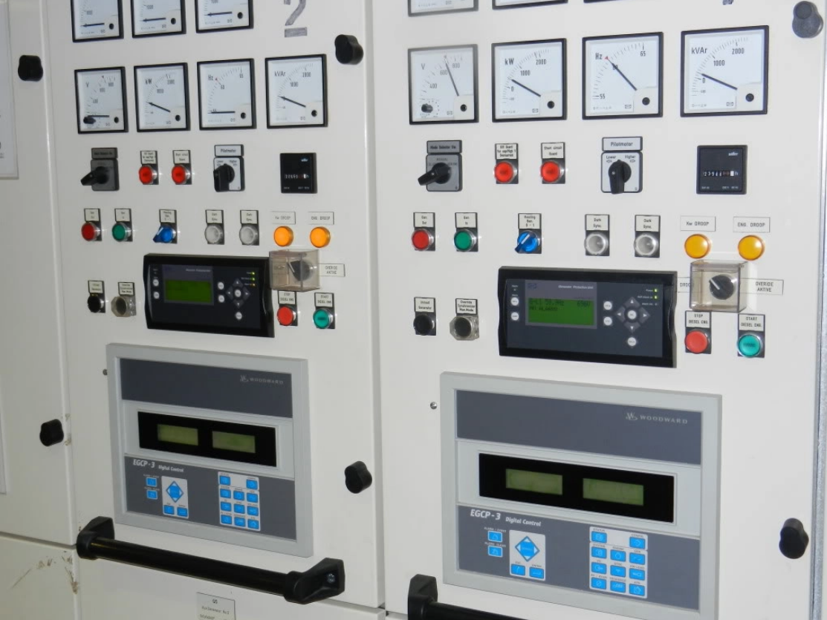

*The generator switchboards for the MPSV Havila Harmony, demonstrating various measurement and monitoring apparatus.*

Although shipboard electronics are rigorously designed with safety in mind under the S.O.L.A.S. convention, there are certain actions and precautions crew should undertake in circumstances where work needs to be performed. One major aspect of safety when working on circuits whose isolator switches have been opened is the L.O.T.O. (Lock On Tag On) convention. This essentially requires all technicians to lock a personalized padlock into a slot on an isolator switch or breaker, and tag the lock with a personal identifier card, as well as keeping rigorous paper logs about when, where and why systems have been disconnected. This ensures that the system where work is being performed cannot be made live, or the machinery activated in a situation which would otherwise place a technician in grave peril. Another interesting aspect is the key of the locks of the L.O.T.O. cannot be cut into a copy, as it is illegal. Trapped key interlocking mechanisms may also be used. Essentially, a trapped key interlock only releases a key when a system has been isolated, and the entrance to the isolated system is only available with that very same key. Triple-trapped key interlock systems add an additional layer of protection by also releasing a key for the technician to carry with him, completely and totally preventing that specific isolator switch from being engaged and subsequently energized.

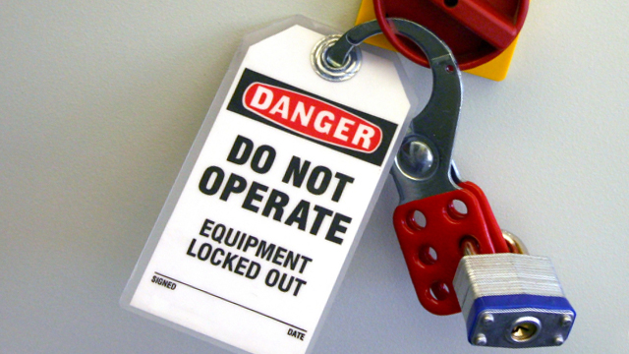

*An example of a folding lockout hasp, with a tag and padlock.*

Furthermore, a technician should employ many traditional and known-to-be-effective tools to ensure safety when working on disconnected equipment. A standard digital multimeter may be employed, with a connection to earth made and testing across all existing phases (e.g. three phases of alternating current) to ensure there is no voltage acting upon the equipment. Also, regular testing for insulation resistance should also be performed with a megohmmeter. It is also good practice to ensure that all tools used for measurements are tested on a known-to-be-live circuit before being used in any real capacity, and once again tested after work to ensure that the results found during the test are confirmed to be free of any fault from equipment failure.

Learning Outcome 2: Recognise and report electrical hazards and unsafe equipment

* Recognise safety hazards which can be present when working on shipboard electrical equipment: electric shock, arc blast, transient overvoltage, and moveable (rotating) parts, environmental factors like high temperature, humidity, water, fuel, steam leaks, rain, wind, and ship rolling or pitching.
* Follow isolation and emergency procedures.
* Explain Lockout/Tag out procedures. *Addressed in Answer 1*

Whilst performing any kind of electrical work it is absolutely paramount that safety precautions and strictly adhered to and hazards are quickly and effectively identified and communicated to others. A great deal of risk can be easily minimized by taking preventative measures. Maintenance schedules should be strictly followed, and ensuring that when working on any job, a work-appropriate level of P.P.E. (Personal Protection Equipment) is adorned. Some of the primary safety hazards that can occur on ships are as follows:

# Electric Shock

Work should never be done on a live circuit unless absolutely necessary. Ensuring that the circuit is completely isolated, and using a multimeter (which has been tested prior and subsequent to operation) to check both between all three combinations of phases, and between all phases and earth. Furthermore, all isolator switches should be tagged on and locked on according to the company’s specific policy. Electric Shock is perhaps the greatest risk to electro-technology officers on ships and electricians on shore. It is therefore absolutely critical that all circuits be treated as live until thoroughly proven dead.

In any situation where someone is a victim of an electric shock, it is absolutely critical for crewmen to act quickly and safely, as the victim’s heart may have stopped and the time before defibrillation and resuscitation may be impossible is approximately four minutes.

1. ***Approach***

*If a coworker or supervisor who is trained in electrical work is nearby, marshal their assistance immediately. The approach to where a coworker has succumbed to electrical shock should be made cautiously to help ensure the current that incapacitated the victim doesn’t harm you too.*

1. ***Examine***

*A quick look at the accident scene will reveal whether the victim remains in contact with whatever shocked him. Avoid any nearby exposed conductors, and don’t touch the victim until the electrical circuits that power the area have been de-energized.*

1. ***De-Energize***

*If the only source of power to the victim’s locale is a power cord or extension cord to portable equipment, simply disconnecting it at the power source may be sufficient. However, a trip to the breaker box to open the circuit may be necessary*

1. ***Insulate***

*In the event that de-energization is impossible, you may have to remove the victim from a live conductor. While this is never desirable, hazards can be controlled by using something that won’t conduct electricity to move the victim and donning insulating gloves and overshoes before attempting rescue if they are available, and exclusively retrieving them with a rescue hook.*

1. ***Rescue***

*Rescues are safest when the power is off and you are standing on insulating material. Don’t ever touch an electrocution victim unless you know the source of electricity that incapacitated them is powered down. If there is a risk of a neck injury or similar contingency, do not move the victim at all. Make sure the victim’s airways are clear of obstruction,. Next, check for breathing and a pulse, then provide CPR or defibrillation if necessary*

“Taking the Shock Out of Electrocution Rescue” Caleb Kimpel, July 25, 2012

*https://www.safetyservicescompany.com/topic/training/electrocution-rescue-should-never-add-another-victim/*

Electric shock is caused by the flow of current through a person’s body. This is frequently from hand-to-hand or from hand-to-foot. A shock current as low as 15 mA (AC or DC) can potentially be fatal.

- Paragraph 3 Page 7 Chapter 1.4 Practical Marine Electrical Knowledge 3rd Edition, Dennis T. Hall

Electric Shock hazards may also arise from subsystems of a particular arrangement being on seperate switchboards, or even specifically designed in such a way that they only energize when a system is disconnected. For instance, on many ships active today, all exterior electric motors are fitted with anti-condensation heaters to protect against moisture intake into the motor’s windings, which is likely to happen if the motor is disconnected for any great length of time. However, in order to have a heater system operate it needs to be a) live and b) separate from the motor’s switchboard. This means that technicians working on that motor may need to de-energize the heater system as well, or perform their work adjacent to live heating elements, creating a great risk of shock or burn. The P.P.E. adorned should reflect this.

# Arc Blast

An arc blast (sometimes referred to as arc flash, or flashover) is an umbrella term for the release of both light and heat energy resulting from an arc fault. A detonation or discharge occurs as a result of a low impedance connection to ground or a different phase across the aether. One of the most common causes of arc-flash injuries occurs when switching on electrical circuits, especially tripped circuit breakers. To avoid this, the fault must be isolated before energizing the circuit. An arc blast may also occur in energized circuits whilst testing and occur due to conductive debris being present. Arc blasts generally do not occur at voltages lower than 220 V, but their likelihood increases exponentially in proportion to the electromotive force in the circuit, as does the distance over the aether the arc fault may occur. The best defense against an arc blast is proper and thorough isolation of any circuit with which an arc fault occurs. Failing this, P.P.E. may be a technician’s last line of defense. Arc Blast body suits are available and should be worn when working on any circuit of sufficiently high voltage (440V or greater) where there is risk of an arc blast.

# Transient Overvoltage

“Overvoltage” is the term used to describe voltage in a circuit which exceeds the maximum voltage, or upper design limit for the particular circuit. Transient overvoltage is a short burst of energy which may occur naturally, especially from lightning, or man-made. These man-made spikes of overvoltage generally occur when inductive loads, such as electric motors or electromagnets. Transient overvoltages significantly degrade and damage electronic systems, and may result in a fire, or electric shock from a flashover if insulation is worn down sufficiently. While generally most ships will have Surge Protection Devices (SPDs), these may need to be replaced if they suffer a great enough overvoltage. A constant routine of checks must be peformed on these SPDs, to prevent electrocution or damage to equipment.

# Environmental Factors

## Electrolysis

* 1. Electrolysis is the process by which a chemical change is induced in a material by way of passing an electric current through it. Sometimes, this process of displacing electrons is known as oxidation. When an electron is displaced, it renders the material inert of charge, also known as neutral. At sea, we are able to combat electrolysis with sacrificial anodes. Seawater acts as an electrolyte and displaces electrons from the sacrificial anode, oxidizing and producing a protective layer. We apply this method to the ship’s hull, the ballast tanks, heat exchangers, etc. Nearly any metal which is likely to encounter a significant amount of corrosion via electrolysis. We often use zinc as the primary metal in the sacrificial anode. Identifying and reporting corrosion to your immediate superior is incredibly important, and will prevent further damage from occuring.

## Weather

### Rain / Moisture / Humidity

While rain and moisture may not cause corrosion, like the sea we travel through, it can create hazards with which we must be aware of and prepare for. Heavy rains may cause visibility issues, making the important of correctly functioning lighting absolutely paramount. It will also cause surfaces to become slippery, and dangerous to tread on. Ensuring that you use the handrailing provided is extremely important, as well. Rain may also cause moisture buildup inside sensitive electronics. In the case of induction motors, ensuring their heaters are functioning correctly and regularly maintained is also very important. In the case of lighting, water may pool at the bottom of the light fixture’s enclosure. In this instance, regular maintenance and checking of seals will help.

### Temperature

As with the weather, temperatures may vary greatly at sea. It is important to understand the limitations of the electronics and machinery aboard ships. Many components have thermal protection units (TPUs) whose maximum safe operation temperatures may be within the realm of achieveable in specific times and places throughout your voyage. It is important to understand that the temperature of a machine will always combine with the ambient temperature. For example, an engine who, at 0 degrees centigrade, has a thermal protection unit which trips at 100 degrees centigrade, and produces enough heat to operate between 50-70 degrees centigrade may actually reach a high enough temperature to trip the TPU on a hot 30-40 degrees centigrade day. It is important to treat every alarm with the severity of a fire until you are able to disprove it is not. On the other hand, during extremely cold seasons, systems may not be able to work at all. In this instance, keeping system heaters well maintained and working when the unit is not in use is absolutely critical to ensuring smooth operations and machine longetivity.

### Heavy Winds / Salt Spray

### Lightning

## Hazards

### Movement of Ship

### Conductive Debris

### Pipe Leakage

### Fuel

### Steam

### Wastewater

# Potentially Hazardous Energy

If the potential exists for the release of hazardous stored energy or for the reaccumulation of stored energy to a hazardous level, the technician must take steps to prevent injury from the release of said energy. Energy in any form becomes hazardous when it builds to a dangerous level or is released in any quantity that could injure a worker. Workers servicing or maintaining machines or equipment may be seriously injured or killed if hazardous energy is not properly controlled. Injuries resulting from the failure to control hazardous energy during maintenance activities can be serious or fatal. Injuries may include electrocution, burns, crushing, cutting, lacerating, amputating, or fracturing body parts, and others.

It's important to understand that electricity is not the only form of hazardous energy employees may encounter during lockout/tagout. Main energy sources that supply power to the entire machine or equipment may be electrical, but secondary energy sources such as pneumatic or mechanical energy may still be stored with the potential to cause injury.

One or more of the following types of energy may require de-energization to completely isolate the equipment. (Note: electricity is intentionally excluded)

* **Chemical**
  + Liquids, such as diesel, acids, and caustics. Gases, such as natural gas. Solids, such as wet and dry cell batteries, and combustible dust.
* **Gravitational**
  + Objects supported by a crane, and elevated platforms. Potential energy is converted to kinetic energy.
* **Hydraulic**
  + Pressurized hydraulic systems, including hoses, pumps, valves, and actuators.
* **Mechanical**
  + Sources such as a spring under compression. Extreme sound is also a hazardous mechanical energy.
* **Pneumatic**
  + Pressurized air or gas systems, including pipes, pumps, valves, actuators, and air compressors, and tank and pipe purging systems.
* **Radiant**
  + Energy that travels by waves or particles, particularly electromagnetic radiation such as heat or x-rays. Ionizing radiation includes alpha and beta particles, computed tomography (CT) and X-rays.
* **Thermal**
  + Hot water, heated oil, steam, and equipment need time to cool, while liquefied gases, such as nitrogen, need time to warm to safe thermal levels.
* **Explosive**
  + The rapid increase in the volume of energy with the generation of high temperatures and the release of gases. Supersonic explosions are called detonations. Subsonic explosions are called deflagration. A boiling liquid vapor expanding explosion is called “B.L.E.V.E.”

Learning Outcome 3: Understand safe voltages for hand-held equipment

* Recognise causes of electric shock and precautions to be observed to prevent shock.
* Describe relationships between shock voltage and shock current.
* Recognise the possibility of the electric shock by the electrostatic charge.
* Explain the influence of shock current on human body.
* Recognise meaning of warning signs.

Answer here

Learning Outcome 4: Understand risks associated with high-voltage equipment and on-board work

* Explain the different voltages on-board and their risks.
* Explain the difference of electric shock caused by low and high voltage.
* Explain the basic parameters of electric arc: the temperature, the energy etc.
* Demonstrate basic understanding of general High Voltage protection measures: housings, partitions, distances, insulation mats, insulation materials, access restrictions, markings and warnings, HV equipment access monitoring and locks.

Answer here